Social media toolkit and online promotion

We need your help to promote our Share Lent 2021 campaign online and on social media, so that we can win the support of as many people as possible for the mission of Development and Peace. The more visibility you can give the campaign, the more people can express solidarity with our sisters and brothers in the Global South.
This social media kit provides all the tools you need to help us spread the word. We invite you to use these tools and messages to promote the Share Lent 2021 campaign on your digital platforms.
In this pandemic time, let's use social media to do good... and share love!
Web promotion
We have created web buttons of various formats that can be used on parish or diocesan websites to promote the campaign. You will find them HERE.
Please ensure that all buttons and banners redirect people to our campaign page, www.devp.org/lent.
Join us on social media!
First of all, make sure that you already follow Development and Peace’s social media accounts:

@DevPeace @devpeace @devpeace

Throughout the campaign, we will share stories, activities and reflections on these platforms.
Helping us share love is simple: enjoy, like, share and comment on our posts.
Stay tuned for our online events.
Visit the events section on our Facebook page or on our website, sign up for our webinars and invite your loved ones to participate too. Check back often to make sure you don't miss anything!

Mark the beginning of the campaign.
The campaign will begin on Ash Wednesday, February 17, 2021. Change your personal Facebook banner to the campaign banner. Download the banner HERE.
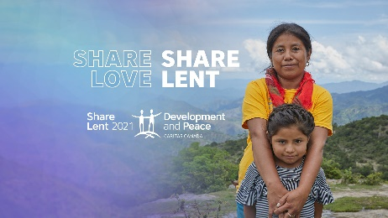
Don't forget to include a link to the campaign webpage (https://www.devp.org/lent) in the image description.
Publish on your pages.
Show your support for Development and Peace by posting on your own pages and groups at various key moments in the campaign. We have developed some campaign messages and visuals to inspire you. All suggested visuals are available HERE.

General message
Twitter  Download  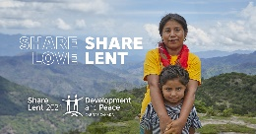 | For #Lent2021, I’m following @DevPeace’s #ShareLent campaign in solidarity with our sisters and brothers in the Global South.  Join me and let’s #ShareLoveShareLent together.  👉 https://www.devp.org/lent
Facebook -Instagram  Download  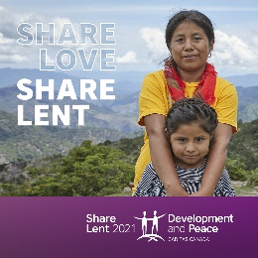 | For #Lent2021, I’m following @devpeace’s #ShareLent campaign in solidarity with our sisters and brothers in the Global South.  Their campaign calendar is jam-packed with prayer, reflections, ideas and activities to engage me and my friends in learning about @devpeace and raising funds for its social, ecological and economic justice projects around the world.  Join us and let’s #ShareLoveShareLent together.  👉 https://www.devp.org/lent

Promote online activities
Twitter  Download | Through #Lent2021, @DevPeace is offering a series of online activities to introduce its partners, its projects in the Global South & the Catholic Social Teaching underpinnings of its work.  I’m following the #ShareLoveShareLent campaign events. Will you?  👉 https://www.devp.org/en/region-events/sharelent2021
Facebook -Instagram  Download | Throughout #Lent2021, @devpeace is offering a series of online activities that introduce its partners; highlight its projects that serve some of our most marginalized sisters and brothers in the Global South; and elaborate the Catholic Social Teaching principles that animate its mission and underpin its work.  Join me in following the #ShareLoveShareLent campaign events. To make sure you don’t miss anything, sign up now:  👉 https://www.facebook.com/events/2862376907352798/

Promote the calendar
Twitter  Download  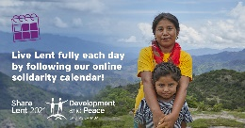 | During #Lent2021, @DevPeace invites us to discover facets of itself and to act in solidarity with people the Global South through prayer, reflection, action & fundraising.  Discover a new possibility every day in the #ShareLoveShareLent campaign calendar: https://www.devp.org/en/lentcalendar-2021
Facebook-Instagram  Download  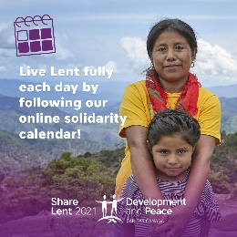 | During #Lent2021, @devpeace invites us to discover facets of itself and to act in solidarity with people the Global South through prayer, reflection, action & fundraising.  This week, [add your own event, activity or idea here].  Discover more possibilities every day in the #ShareLoveShareLent campaign calendar: https://www.devp.org/en/lentcalendar-2021.

Message for Solidarity Sunday
Twitter  Download | It’s #SolidaritySunday! Please don’t forget to donate to the #ShareLoveShareLent campaign.  Your generosity will help @DevPeace to continue supporting our poorest sisters and brothers in the global south.  👉 https://www.devp.org/give
Facebook  Instagram  Download | Today is #SolidaritySunday, an important landmark in the #Lent2021 journey. Today is the day we give concrete expression to our solidarity with the poor.  Please donate to the #ShareLoveShareLent campaign. Your generosity will help @DevPeace to continue supporting our most vulnerable sisters and brothers in the Africa, Latin America, Asia and the Middle East.  👉 https://www.devp.org/give

- If you will be watching a mass streamed on any online platform that allows live commenting, use one of the following messages to invite people to donate:
Message 1 (Facebook or YouTube) | Please remember to donate to Development and Peace’s Canada-wide #ShareLent campaign. To donate, visit devp.org/sharelent, call 1 888 234-8533 or mail a cheque to Development and Peace (find the address on their website). Thank you for your generosity. 🙏
Message 2  (Facebook or YouTube) | This #Lent2021, #ShareLove and donate to Development and Peace – Caritas Canada to show solidarity with our brothers and sisters in the Global South. Visit devp.org/sharelent to donate and directly support some of the poorest communities in over 30 countries in Africa, Asia, Latin America and the Middle East. Thank you for your generosity. 🌎 🙏
Other ideas
- Have you created a fundraising page on our online platform? Don't forget to share it on your social media pages. Invite your friends and family to donate and to promote your page on their social media accounts!
- Is your parish organizing any local events (online or in person)? Is your school doing a THINKFast? Don't forget to announce and promote it all on social media!
- Are your friends and family following Development and Peace on social media? Don't hesitate to invite them to like our page or to tag them on posts that might interest them.

