The news bulletin for your parish is an excellent medium for promoting the Share Love, Share Lent campaign. Ask to have the following weekly announcements published in your bulletin. Feel free to adapt the text for your local context and needs.
The images shown here are illustrative only. For publishing in the bulletin, please use the higher-resolution images in this online folder.

WEEK 1: FEBRUARY 17 TO 21, 2021
Share Love, Share Lent: (Re)discover Development and Peace.
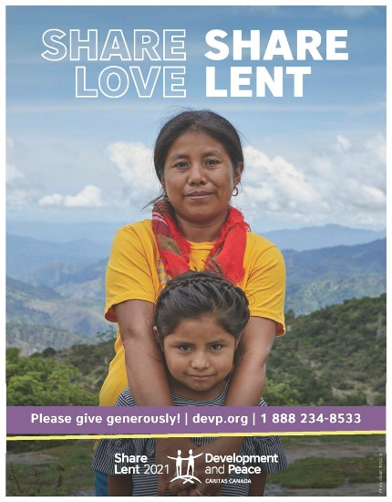
The Share Love, Share Lent campaign is inspired Pope Francis’s encyclical, Fratelli Tutti and its call “for a love that transcends… geography and distance” and “allows us to acknowledge, appreciate and love each person.”
Each week, the campaign explores a different aspect of Development and Peace’s work and offers you ways to become involved. This week, meet one of our partners from the Global South and create your own fundraising web page!
Discover more activities and join Catholics across Canada on a journey of love and solidarity throughout the Lenten period.
Follow our solidarity calendar at devp.org/lent.

WEEK 2: FEBRUARY 22 TO 28, 2021
Share Love, Share Lent: Solidarity with communities in crises.
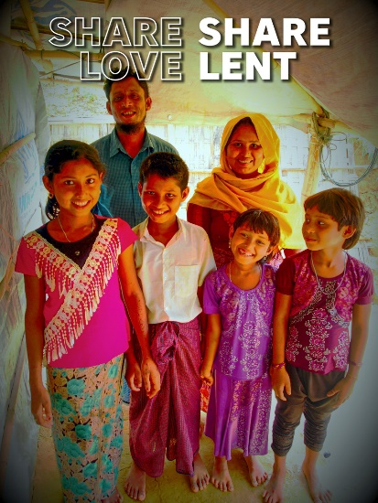
Did you know that Development and Peace provides humanitarian aid to communities coping with climate change, conflict and natural disasters in over a dozen countries?
This week, the Share Love, Share Lent campaign looks at how your solidarity is meaningful for Rohingya refugees and their host communities in Bangladesh.
Please pray for communities affected by crises and help us to keep supporting them by contributing to the collection on the Fifth Sunday of Lent.
For inspiration, information and to donate, visit devp.org/lent.

WEEK 3: MARCH 1 TO 7, 2021
Share Love, Share Lent: Strengthening vulnerable communities.
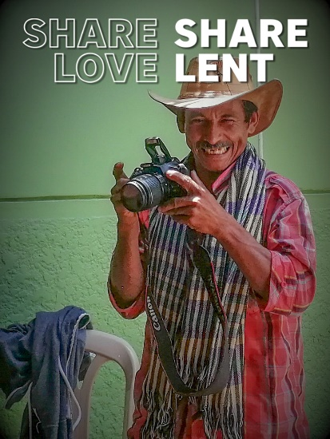
Did you know that Development and Peace supports a school for peasant filmmakers in Colombia?
This week in the Share Love, Share Lent campaign, discover the creative ways in which we assist communities in speaking for and taking charge of their own development.
In keeping with the Catholic Social Teaching principle of participation, let your Lenten journey make a difference in the world. Learn about our work and consider giving to help sustain it.
Discern and donate at devp.org/lent.

WEEK 4: MARCH 8 TO 14, 2021
Share Love, Share Lent: The passion of youth.
Did you know Development and Peace has an active youth movement from coast to coast?
The Share Love, Share Lent campaign celebrates the passion and commitment of youth, who represent the present and the future of the Development and Peace movement. Join them in supporting our work for positive change in Canada and the Global South.
Start a solidarity letter chain in aid of Development and Peace.
Learn how at devp.org/chainletter.

WEEK 5: MARCH 15 TO 21, 2021
Share Love, Share Lent: Raise a toast to yourself!
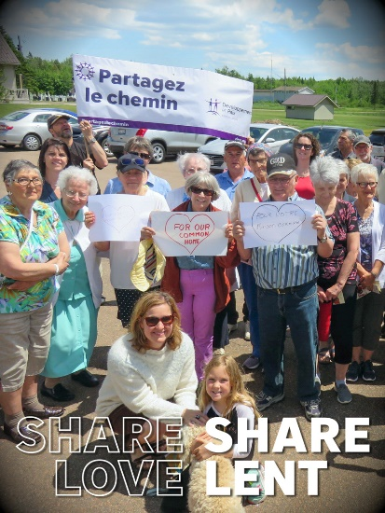
Did you know that over 10,000 Canadian Catholics like you are members of Development and Peace?
The Share Love, Share Lent campaign invites you to pray for them and to honour their solidarity towards our sisters and brothers in the Global South.
Show your support by donating generously this coming Solidarity Sunday. You can also become a monthly donor and have your year-long contribution matched, thanks to the support of religious communities across Canada. Not only will you double your impact, but you will also automatically become a member of Development and Peace!
Learn more at devp.org/lent.

WEEK 6: MARCH 22 TO 28, 2021
Share Love, Share Lent: Keeping Canadians committed.
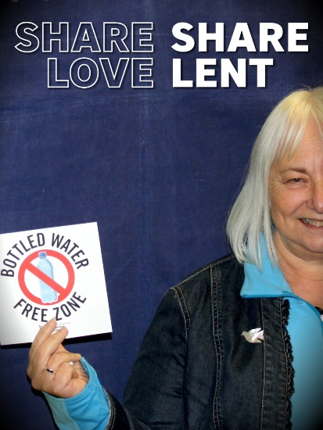
Did you know that advocacy by Development and Peace members resulted in several schools, parishes and municipal offices across Canada giving up bottled water?
Join our Share Love, Share Lent campaign to celebrate the many ways in which Canadian Catholics show that they care for social, economic and environmental justice
To help make a difference, get your MP to commit to building back better from the pandemic.
Visit devp.org/lent to learn more.

WEEK 7 (HOLY WEEK): MARCH 29 TO APRIL 4, 2021
Share Love, Share Lent: Paschal progression.
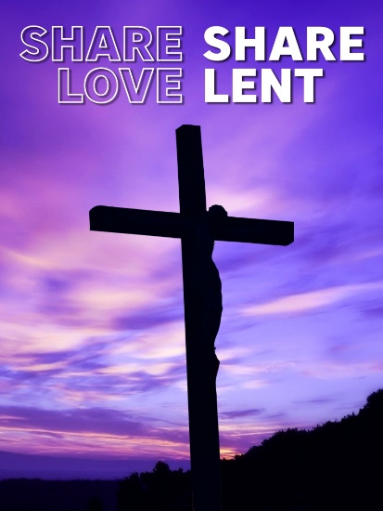
Did you know that Development and Peace has organized a Lenten campaign every year since 1968?
Keeping up with the tradition, this year’s campaign, Share Love, Share Lent, invites you to a final week of family fun, communal reflection, global solidarity and prayer.
Don’t miss our special campaign Way of the Cross!
Catch the details and contribute at devp.org/lent.

THANK YOU NOTE
Thank you for sharing love this Lenten season!
The Share Love, Share Lent campaign called you to share love, and you opened your hearts.
Our parish raised $______ for Development and Peace!
This money will help sustain programs and projects that serve some of our most vulnerable sisters and brothers in the Global South!
Thank you for your generosity.
If you have not already done so, please consider making a donation at devp.org/lent.

