MESSAGES FOR PARISH BULLETINS
We invite you to ask your parish to publish the following messages in its virtual or paper parish bulletin to promote Development and Peace — Caritas Canada’s People and Planet First campaign. You can adapt these messages to suit your needs.

Week of September 26
Let’s put People and Planet First with Development and Peace — Caritas Canada’s new campaign!
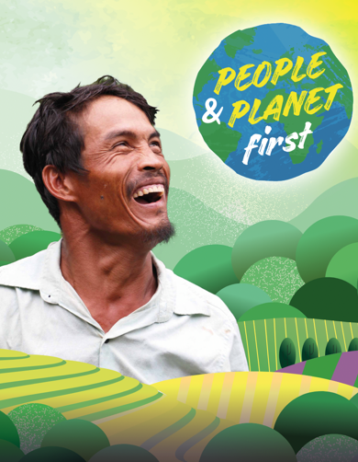
In Canada, most people can speak out freely when injustice is committed. In many countries of the Global South, however, communities are threatened when they seek to protect their rights, especially their right to a healthy environment. This climate of insecurity is often fuelled by the presence and influence of corporations, some of which are Canadian.
Undaunted, many vulnerable communities fight courageously to defend their rights, their lands and the environment against corporate harm.
This year, Development and Peace’s People and Planet First campaign invites you to stand in solidarity with them and celebrate their work!
To learn more about the campaign, join us for an in introductory workshop at [TIME] on [DATE] at [PLACE]. The campaign poster is available for download on Development and Peace’s website for promotion! For more information, contact: [CONTACT NAME and CONTACT INFORMATION] or visit https://www.devp.org/en/campaign/people-planet-first/.

Week of October 3
As we end the Season of Creation, let’s pray for social and environmental justice
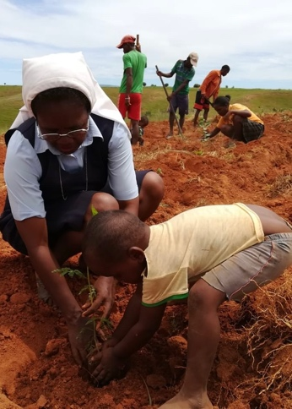
The Season of Creation, which lasts from September 1 to October 4, is a time for the global Christian family to unite in prayer and action for the Earth, our shared home. This year, in the face of continuing environmental destruction, Development and Peace’s People and Planet First campaign is seeking to ensure that Canada and Canadian corporations are not complicit in any violations of the rights of the people and the planet while operating abroad.
To learn more about the campaign and to pray and act for the preservation of Creation, visit Development and Peace’s new website. There, you will find a multitude of resources to help you live the Season of Creation to the fullest and to mobilize for putting people and planet first. Especially take a look at our compilation of prayers celebrating the Earth and invoking its protection! Visit https://devp.org/en for more.

Week of October 17
Let’s stand with the oppressed in their quest for recognition
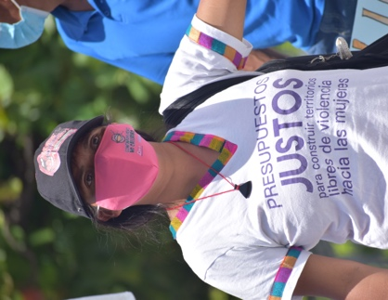
In Honduras and Cambodia, organizations supported by Development and Peace are raising the voices of communities oppressed by a model of economic development that violates their rights. The Honduran Center for the Promotion of Community Development (CEHPRODEC) trains environmental leaders to defend natural resources, the environment and human rights. In Cambodia, Development and Partnership in Action (DPA)’s mission is, in part, to enable communities affected by extractive industries to gain advocacy skills so they can organize and defend their rights.
We can support these partners by recognizing the role we can play in an unjust global system and taking action to change it. This year, the action highlighted by the People and Planet First campaign is about holding Canadian companies accountable for their operations abroad - to ensure that Canada is not complicit in the violation of the rights of our brothers and sisters. Get involved at https://devp.org/en

Week of October 24
Together, let’s act for the planet and its defenders!
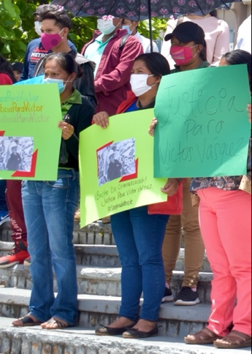
Development and Peace’s annual People and Planet First campaign is inspired by the words of Pope Francis, who says that “a true ecological approach always becomes a social approach; it must integrate questions of justice in debates on the environment, so as to hear both the cry of the earth and the cry of the poor” (Laudato Si’, 49). These cries are too often silenced by powerful companies that plunder resources in countries of the Global South, without regard for people’s fundamental human and environmental rights. Many such companies are Canadian.
Act to end their impunity now! Sign the petition asking the federal government to enact laws that will compel Canadian companies to conduct due diligence across their overseas operations and that will give the victims of their abuses access to justice in Canadian courts. Visit https://devp.org/en

Week of October 31
Let’s listen to the voices of our brothers and sisters fighting for their right to a healthy environment
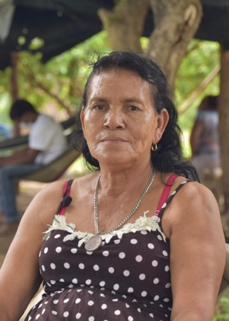
World leaders have gathered for the 26th UN Climate Change Conference of the Parties (COP26). Although these powerful decision-makers are debating the future of the planet, they are probably too far removed from the realities of its most vulnerable people. It is up to us to hear and amplify the voices of those who are defending their rights and the environment against economic ravage.
Medarda Hernandez, whose community in Honduras has been repeatedly harmed by large industrial projects, including supposedly “green” projects, says, “if other extractivist projects start in our community, we are not going to let them pass. I ask the international community to come to our aid, because we are really suffering from this situation.”
So that people like Medarda do not go unheard, let’s make Canadian companies operating abroad responsible for protecting human and environmental rights. Join Development and Peace’s People and Planet First campaign to make this happen. Visit https://devp.org/en to learn more.

Week of November 14
Let’s spread the word about putting People and Planet first
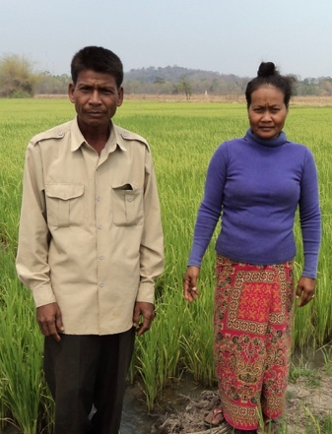
Development and Peace's 2021-2022 campaign, People and Planet First, is calling for Canada and cCanadian corporations not to be complicit in violations against the planet and its inhabitants The easiest way to take action is to sign the petition calling on the government to implement a due diligence law that would require its companies to respect human and environmental rights in their overseas operations.
However, there are several other options available to you if you have already signed and want to continue your commitment! You can follow the latest campaign news on our Facebook or Instagram pages and even update your profile to show the campaign colors. If you’d like to delve into the subject deeper, take the time to read our printable backgrounder. And what about sharing the campaign video with your friends and family? Whatever you choose to do, thank you for helping to spread solidarity! https://devp.org/en

Week of November 28
Thank you for putting People and the Planet First
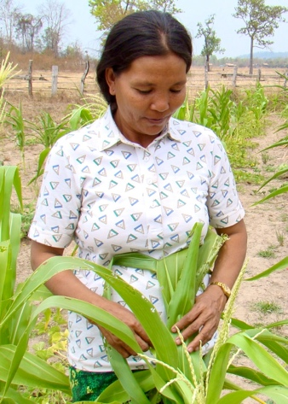
A major focus of Development and Peace — Caritas Canada’s People and Planet First campaign is advocating for a law that compels Canadian companies to respect the human and environmental rights of local populations in their overseas operations. This fall, acting in solidarity with their brothers and sisters in the Global South, thousands of Canadians signed a petition asking the government to enact such a law.
On behalf of all those who struggle to preserve their land, lives, livelihoods and lifestyles, Development and Peace — Caritas Canada thanks you for your commitment and mobilization. Together, we act in solidarity with the protectors of the Earth. Together, we have the power to change lives.
To continue supporting the petition and to keep up the campaign momentum, visit https://devp.org/en

