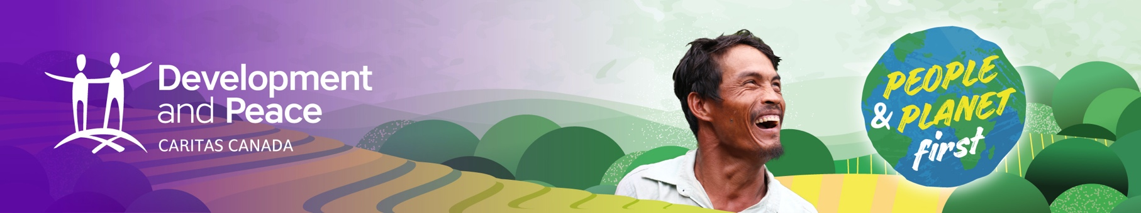

Short talk
Hello,

My name is _________, and I am speaking to you today on behalf of Development and Peace – Caritas Canada in the context of its annual campaign.

Every week, four people are murdered somewhere in the world simply because they were defenders of human and environmental rights trying to defend their communities. This climate of insecurity is often fuelled by the presence of mining, agribusiness or textile companies among others, some of which are Canadian. It is important that Canada makes sure that Canadian companies respect human and environmental rights in all their activities in the Global South and thus contribute to what Pope Francis calls an “ecological conversion.”

Throughout the fall, you will have the opportunity to take action alongside our sisters and brothers in the Global South who are fighting for their rights and the preservation of Mother Earth by joining the People and Planet First campaign.

Why is it important for Canada to have a legal requirement that obliges Canadian companies to act responsibly abroad? Because enacting such a law would help protect the men and women defending the earth by giving them a right of recourse to Canadian courts. Life before profit! That is the message these people are sending us from their communities.

So, what are we waiting for? This fall, several international meetings will be taking on the climate, including COP26. We can challenge our elected officials and raise awareness in our communities about the climate emergency. We can listen and express our solidarity with our sisters and brothers affected by environmental destruction. As Pope Francis says in his encyclical Laudato Si', we must know how to hear “both the cry of the earth and the cry of the poor.” That cry is too often silenced.

In countries such as Honduras and Cambodia, Development and Peace’s partners are accompanying environmental leaders in defending their rights. However, as residents of a Northern country, we can take action right here to share in that responsibility, which is also our own — to stand up for these people who are fighting to preserve rivers, forests, wildlife and plants.

Let’s act now by signing the petition asking the Canadian government to implement a due diligence law that would require Canadian companies to respect human and environmental rights in their overseas operations! To learn more and take action, visit the campaign website at devp.org. You can also join your local Development and Peace group to mobilize this fall — we need you to carry this emphatic message: People and Planet First!

Thank you for listening.

1425, René-Lévesque Blvd. West, 3rd floor
Montreal, Quebec H3G 1T7
1 888 234-8533 | info@devp.org | devp.org

Please print double sided.

