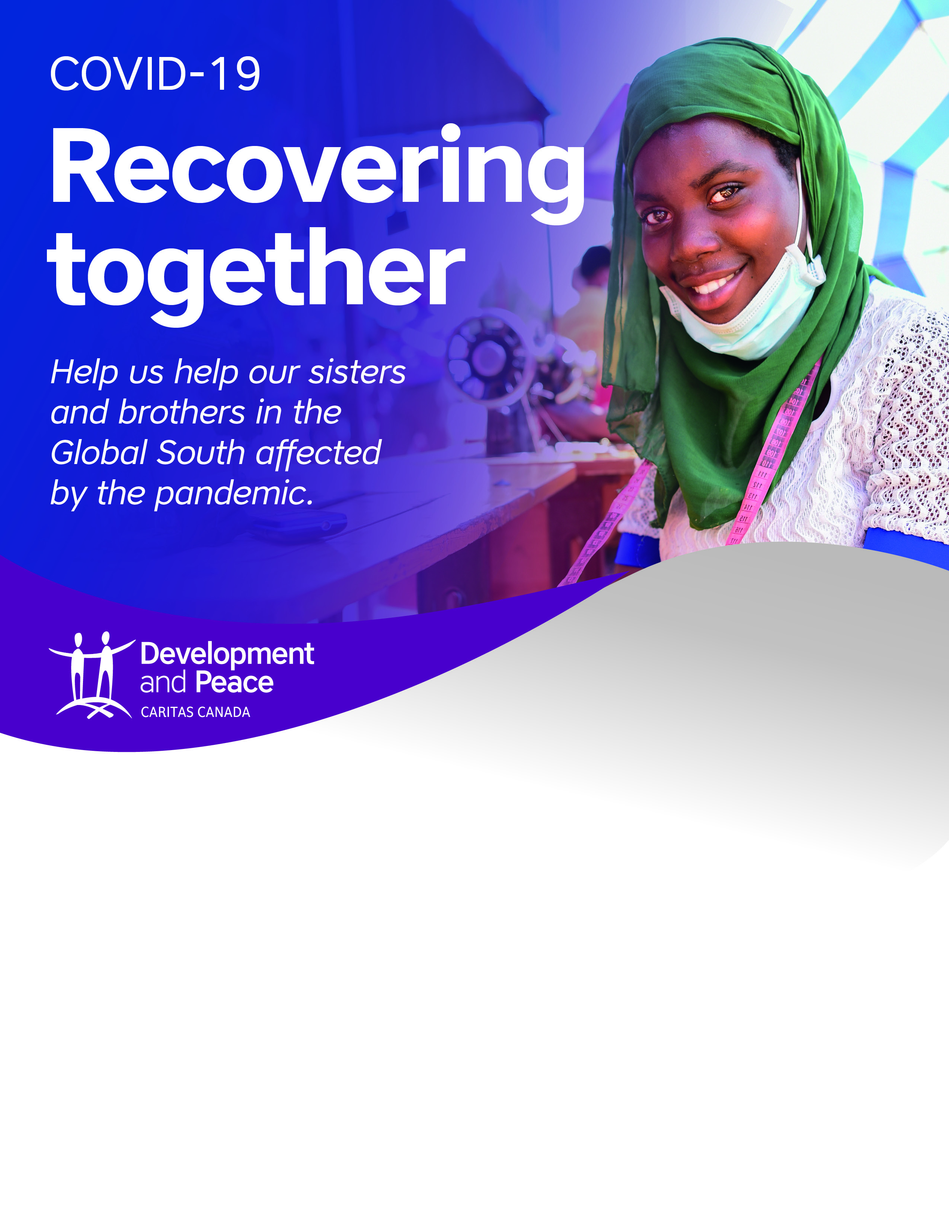

For more information, please contact:

Photo: Caritas Internationalis