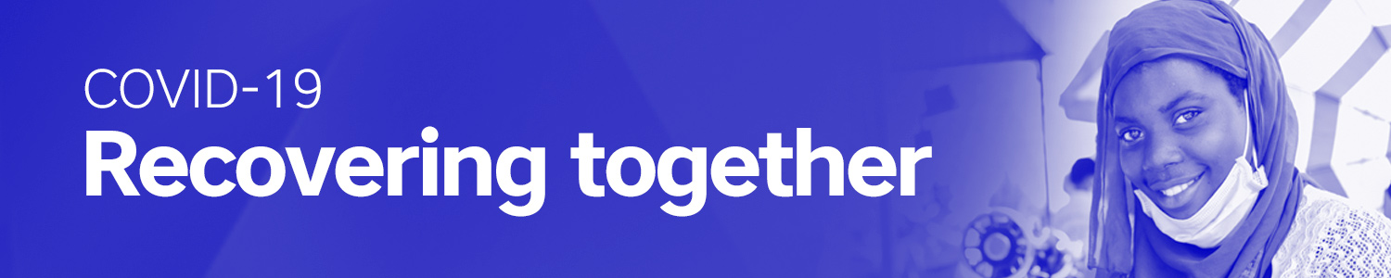
Short Talk
Hello!

Today our bishop invites you to make a donation to Development and Peace – Caritas Canada after mass. This is a special collection to support our sisters and brothers in the Global South who have been affected by the COVID-19 pandemic.

The pandemic has changed all our lives. Everyone has suffered. But it has also shown us that those who were marginalized to begin with have suffered the most.

- How can you wash your hands when you do not have access to soap and clean water?
- How can you practice physical distancing when you live in a refugee camp?
- How can you get medical attention when there is no access to health care?
- How can you feed your family when you are locked down with no social safety net?
- How can you protect yourself without access to public health information?

With your support, Development and Peace is helping to answer all these questions in Latin America, Africa, Asia and the Middle East.

This virus has taught us how interconnected our human family is. It has taught us that we cannot recover alone. As Pope Francis said: “An emergency like that of COVID-19 is overcome with, above all, the antibodies of solidarity¹.”

How will we recover if not together? Recovering together is essential if we are going to defeat this virus in our interconnected world.

Thank-you for your generosity and support. I invite you to visit devp.org to learn how your donation is helping to ensure that we are recovering together as one human family.

(Give instructions on how to make the donation: e.g. collection box at the back of the church or online at devp.org)
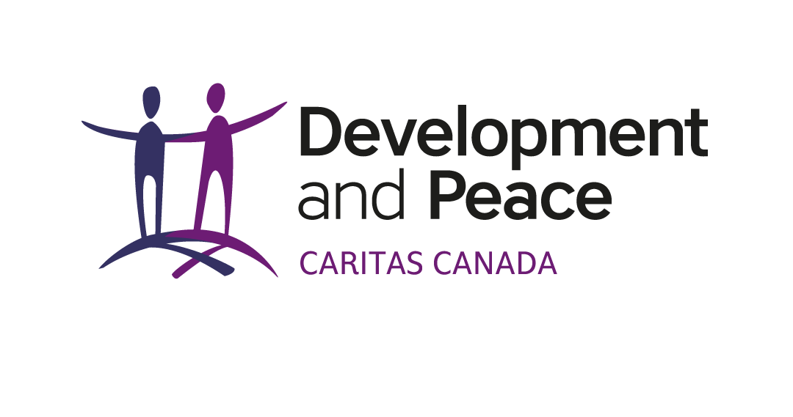
___________________________________
¹ Pope Francis, Pontifical Academy for Life, Global Pandemic and Universal Brotherhood. Note on the COVID-19 Emergency, 30 March 2020, 5.

